English Booklist 2016-17
The pupils of all levels from P1 to P5 will need:
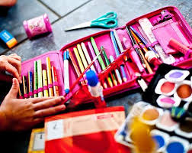

A good pencil case
Plastic folder for notes etc
Folder (binder)
Hard backed copy book
Glue stick X 3
Pencils x3
Rubber
Pencil sharpener
Colouring Pencils
Green pen (not Maternelle and P1)
Ruler
Scissors

In addition for P5 :

P5 Geometry Set
P5 Blue pen

Bank details to transfer 100 € stating the TEACHER And CLASS LEVEL and CHILD'S NAME to:

P1 Ms.Ni Bhriain and Ms.Coyne
BE71 7360 2025 4169 -100 Euro

P2 Ms. McQuiston
BE56 3770 5420 8788 -100 Euro

P3 Ms. Gray-BE26 0017 3508 0729 -100 Euro

P4 Ms. Ojja- BE09 3630 9447 9757-100 Euro

P5 Ms. Marie Louise Candon -100 Euro
BE52 7370 4489 7909
